**STUDY GUIDE FOR MODULE NO. 10**

**EMERGING TECHNOLOGY IN HEALTH**

**MODULE OVERVIEW**

Emerging technologies in healthcare are reshaping the industry across various fronts. Telemedicine is enhancing remote patient care and accessibility, while AI-driven medical diagnosis is revolutionizing disease detection and personalized treatment recommendations. Precision medicine tailors treatments to individuals, leveraging genetic and environmental data. Health wearables and remote monitoring offer real-time health insights, and robotics enable precision surgery. Virtual reality is facilitating therapy and rehabilitation, while nanomedicine is advancing treatments at the molecular level. These technologies hold the promise of improving patient outcomes, expanding healthcare accessibility, and increasing system efficiency, albeit with ethical and regulatory considerations to address as they continue to evolve.

**MODULE LEARNING OUTCOMES**

Upon completion of this module, Emerging technology in health, learners should be able to:

* Understand the key subtopics in emerging healthcare technologies, including telemedicine, AI in medical diagnosis, precision medicine, health wearables, robotics in surgery, virtual reality therapy, and nanomedicine.
* Explain the advantages and applications of each of these emerging technologies in the healthcare industry.
* Gain an appreciation of the potential impact of these technologies on patient care, healthcare accessibility, and overall system efficiency.
* Discuss the ethical and regulatory considerations associated with the integration of emerging healthcare technologies.
* Be encouraged to explore and critically analyze recent advancements and trends in each of these healthcare technology areas, as well as their implications for the future of healthcare.
* Learn to evaluate the potential benefits and challenges of adopting these technologies in different healthcare settings and understand the role of healthcare professionals in utilizing them effectively.

**TELEMEDICINE AND TELEHEALTH**

**History of Telemedicine**

The field of telemedicine has changed significantly since its inception. Just about 50 years ago, some hospitals began experimenting with telemedicine to reach patients in remote areas. But with the rapid development of technology in recent decades, telemedicine has evolved into a complex, integrated service used in hospitals, homes, private doctors' offices, and other health care facilities.  
  
The concept of telemedicine arose with the advent of telecommunications technology, a means of sending information remotely in the form of electromagnetic signals. Early forms of telecommunications technology included telegraph, radio, and telephone. In the late 19th century, radio and telephones were just beginning to emerge as viable communications technologies. Alexander Graham Bell patented the telephone in 1876 and Heinrich Rudolf Hertz made the first radio transmission in 1887.  
  
But it was not until the early 20th century that the general population became interested in these technologies and imagined that they could be applied to the field of medicine. In 1925, the cover illustration of Science and Invention magazine featured a strange invention by Dr. Hugo Gernsback called a "teledactyl". This imaginary tool would use slender robotic fingers and radio technology to examine patients remotely and show doctors a video feed of the patient. Although this invention never went beyond the concept stage, it anticipated the common definition of telemedicine that we think of today: remote video consultations between doctors and patients. A few decades later, in the 1950s, several hospital systems and academic medical centers were experimenting with how to put the concept of telemedicine into practice. Medical staff at two different medical centers in Pennsylvania, about 24 miles apart, transmitted X-ray images over the phone. In the 1950s, a Canadian doctor used this technology to create a teleradiology system used in and around Montréal. Then, in 1959, doctors at the University of Nebraska were able to transmit neurological tests to medical students on campus via two-way interactive television. By 1964, they had built a telemedicine link that allowed them to provide medical services to Norfolk State Hospital, 110 miles from campus. Initially, healthcare professionals developed this technology to reach remote patients living in rural areas. But over time, health care workers and the U.S. government came to understand the bigger picture: the opportunity to reach urban populations facing health care shortages and respond to health care shortages. medical emergencies by promptly sharing medical advice and patient medical records. In the 1960s, major investments by the US government, including the Department of Public Health, NASA, the Department of Defense, and the Department of Health and Human Sciences, spurred research and innovation in the field. telemedicine. Emergency heartbeat sending begins around this time. In Miami, for example, University Medical Center collaborated with firefighters by sending ECG signals over voice radio channels at emergency locations. One particularly successful government-sponsored telemedicine project is called Space Technologies Applied to Advanced Rural Health Care Papago (STARPAHC) and is a collaboration between NASA and the United States Medical Service. Indian economy. The program has funded telemedicine services for Native Americans living on the Papago Reservation in Arizona and astronauts in space! Projects like STARPAHC have spurred medical engineering research and helped expand advances in telemedicine. The following decades saw continued innovations in telemedicine and research more broadly at universities, medical centers, and research companies.

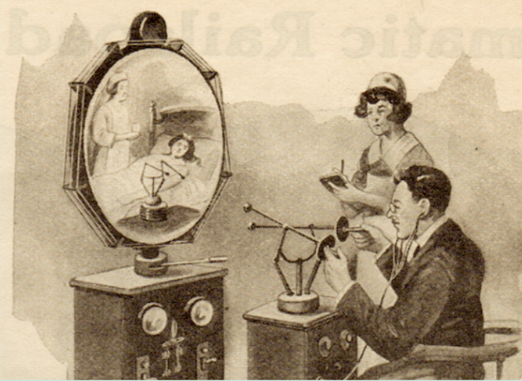

*Figure 1. Teledactyl by Dr. Hugo Gernsback*

**Telemedicine Today**

Telemedicine was originally created to treat patients in remote locations, far from local healthcare facilities, or in areas lacking healthcare professionals. Although telemedicine is still used to address these issues today, it is increasingly becoming a convenient medical care tool. Today's connected patients want to spend less time in the doctor's waiting room and get immediate care for small but urgent problems when they need it.  
Expectations for more convenient care, combined with a lack of overburdened health care professionals (especially primary care providers), have led to the rise of telemedicine companies. Many offer patients 24/7 access to medical care with an on-call physician employed by that company. Others provide large hospitals and medical centers with access to additional clinical and specialist staff to outsource handling of individual cases (a common model among companies teleradiology). Still others offer telemedicine platforms that doctors can use to provide virtual visits to their patients. Increasingly, telemedicine is a way to give medical practices an edge in a competitive healthcare landscape where it can be difficult to maintain independence or maintain healthy outcomes.  
The growing field of mobile health is also influencing the growth of telemedicine. With the variety of mobile health apps and new user-friendly mobile medical devices, patients are starting to use technology to monitor and track their health. Simple medical devices for home use, capable of taking vital signs and diagnosing ear infections, monitoring glucose levels or measuring blood pressure, allowing patients to gather needed medical information necessary for a doctor's diagnosis without having to visit a doctor. And again, as more patients use technology to manage their health, they will also become more open to other ways of receiving care – through telemedicine!

**What is Telehealth?**

In layman's language, telemedicine and telemedicine are terms that represent the transfer and exchange of medical information between different sites. From the perspective of the American Telemedicine Association; Telemedicine, as well as telemedicine, is defined by the transmission of still images, patient consultations via video conferencing, patient portals, remote control, and vital signs monitoring, continuing medical education, patient-based wireless focused applications, nursing call centers and many other applications.

The existence of telehealth dates to the 1960s, with one of the first applications being to monitor astronauts' physiological parameters. Over the years, thanks to technological advances, several technology and communication tools have been deployed to enable the transmission of patient information for recommendation and consultation purposes in most settings and specialties. medical. Patient telehealth services can also provide remote patient monitoring, consumer health information and communications, and medical education for providers. Typically, delivery techniques include networked programs connecting tertiary medical centers to peripheral centers and clinics in rural areas, home video phone connections, point-to-point connections to hospitals and clinics, Web-based e-health service pages and home monitoring links.

**Differences of Telemedicine and Telehealth**

With interrelated fields such as mHealth, digital health, health IT and telemedicine all constantly evolving with new developments, it can sometimes be difficult to find definitions for these terms. In much of the healthcare industry, the terms “telemedicine” and “telemedicine” are often used interchangeably. In fact, even the ATA considers them to be interchangeable terms. This is not surprising because the definition of telemedicine and telemedicine include very similar services, including: medical education, electronic health patient monitoring, patient consultation by video conferencing, wireless health applications, visual medical report transmission, etc.

Telehealth may involve more general health services, like public health services, whereas telemedicine is a specific kind of telehealth that involves a clinician providing some kind of medical services.

Telemedicine:

* A public health app that alerts the public in the event of an epidemic
* Video conferencing platform for medical training

Telemedicine:

* A mobile application that allows doctors to treat patients remotely via video chat.
* The software solution allows primary care providers to send photos of rashes or moles to a dermatologist at another location for rapid diagnosis.

**Pros and Cons of Telemedicine**

**PROS**

* More convenient, accessible care for patients.

Making healthcare more convenient and accessible for patients is driving the field of telemedicine. Telemedicine was initially developed in the United States to address health care shortages, especially in isolated rural areas. Today, telemedicine is used worldwide, from providing basic healthcare in third world countries to allowing elderly patients with limited mobility to Transfer to see a doctor at home. Not only does telemedicine have the potential to eliminate common geographic barriers to accessing care, but it also makes the entire healthcare delivery model more convenient for patients.

* Saves on Healthcare costs.

The United States spends more than $2.9 trillion on health care each year, more than any other developed country. Additionally, an estimated $200 billion of these costs are avoidable and unnecessary. Telemedicine has the potential to reduce our healthcare costs by reducing problems such as medication non-adherence and unnecessary emergency room visits, while also making traditional doctor visits more efficient. more effective.

* Extends access to consults from specialists.

Through telemedicine, a physician office or hospital system can immediately expand access to appropriate medical professionals. This makes it easier for primary care physicians to consult with medical specialists about a patient's case and for the patient to see the specialist needed for a rare, unusual form of cancer. Tell them where they are. As another example, small hospitals that do not have enough radiology staff can outsource evaluation of X-ray results through telemedicine.

* Increasing patient engagement.

Today's patients live in an increasingly connected world and expect a different kind of care experience. Telemedicine engages patients by allowing them to communicate with their doctors more frequently and conveniently. That means more questions are asked and answered, the doctor-patient relationship is stronger, and patients feel empowered to manage their care.

* Better quality patient care.

Telemedicine makes it easier for providers to follow-up with patients and make sure everything is going well. Whether they’re using a more extensive remote patient monitoring system to watch the patient’s heart or doing a videochat to answer medication questions after a hospital discharge – telemedicine leads to better care outcomes.

**CONS**

* Requires technical training and equipment.

Like most technology solutions, telemedicine platforms often require training and equipment purchases. This really depends on the solution: a larger inpatient telemedicine platform will be used among GPs and consultants may need training add and purchase telemedicine carts and various mobile medical devices. Secure video chat apps like eVisit require much less employee training and often only require the purchase of a webcam.

* Some telemedicine models may reduce care continuity.

Consumer-facing telemedicine companies offer huge benefits for on-demand care for patients. A sick patient can simply go online and request to see one of the telemedicine company's doctors and seek treatment. But this model, similar to the health retail movement, leads to a breakdown of continuity of care. A random doctor who doesn't know the patient won't know their entire medical history. The best approach to telemedicine? Provide tools for providers to easily connect with their patients.

* May reduce in-person interactions with doctors.

Some critics argue that online telemedicine interactions are impersonal and that a physical examination is often necessary to provide a full diagnosis. If more patients use online interactions instead of in-person visits, what impact will that have?

Direct examination between patient and doctor is clearly useful and necessary in many cases. Telemedicine is best used to supplement these visits – to perform simple check-ins with patients and make sure everything is going well. For mild acute conditions (such as infection), in-person examination with an established patient is usually not necessary. In these cases, telemedicine can save time and money for patients, doctors, and the healthcare system.

* Navigating the changing policy and reimbursement landscape can be tricky.

Reimbursement for telemedicine is a difficult topic, especially with ever-changing national policies. Many states now have parity laws that require private payers to reimburse telemedicine visits the same as in-person visits. The best way to navigate reimbursement is to call your top payers and ask them what their policies are. You can also see our guide to telemedicine reimbursement and this helpful matrix from the ATA on state policies. It's important to note that many doctors who use telemedicine services charge patients’ convenience fees, ranging from $35 to $125 per visit. These fees are paid directly by the patient and are in addition to (or in lieu of) any reimbursement through the payer. While this means patients have to pay out of pocket, many eVisit customers find that it doesn't bother them and are actually willing to pay the extra fee for the convenience.

**What services can be provided via telemedicine?**  
Telemedicine can be used for many types of healthcare services. Here is a short list of common conditions that a primary care physician can treat through telemedicine:

Allergy  
Arthritis  
Asthma  
Bronchitis  
Colds and flu  
Diarrhea  
Infection  
Central base  
Sore throat  
Conjunctivitis  
rash  
Respiratory tract infections  
Sinusitis  
Dermatitis  
Cellulite  
Sore throat  
Sprains and strains  
Bladder infection  
urinary tract infection  
Sports injuries

**How telemedicine works/How to use it/Types of telemedicine**

* **Network program**

Network connections (such as high-speed Internet lines) are often used to connect remote medical clinics with larger medical facilities such as urban hospitals. According to the ATA, there are approximately 200 networked telemedicine programs in the United States, providing telemedicine access to more than 3,000 rural locations.

* **Point-to-point connection**

Point-to-point connections connect small, remote medical centers to large central medical facilities via high-speed Internet. This type of telemedicine connection allows smaller or understaffed clinics to outsource medical care to specialists at other locations within the same health system. Point-to-point connections are especially popular for telepsychiatry, teleradiology, and urgent care services.

* **Link to monitoring center**

Links to monitoring centers used for a type of telemedicine: remote patient monitoring. This type of telemedicine link creates a digital connection between the patient's home and the remote monitoring center, so that the patient's medical data can be measured at home and transmitted electronically to the center in a timely manner. Remote medical monitoring. These links are usually in the form of an Internet, SMS or phone connection. They are commonly used to monitor medical data about the lungs, heart, or fetus.

**Types of Telemedicine Consultations**

* **Store-and-forward**
* **Remote patient monitoring**
* **Real-time telehealth**

**Store-and-forward**

Sometimes called asynchronous telemedicine solutions, store-and-forward solutions enable healthcare providers to transmit and share patient medical data (test results)., images, videos, recordings) with a supplier in another location. These platforms provide a type of sophisticated and secure messaging platform – a way to securely share private patient data online.

The term asynchronous refers to the fact that the consultant, patient and treating physician do not need to communicate at the same time. Also, consider a phone call rather than an email exchange. A (synchronous) phone call requires all parties to communicate in real time, while an email exchange does not. Store-and-forward telemedicine works best for multispecialty medical services in which the provider must delegate diagnosis to a specialist. For example, teleradiology relies heavily on store-and-forward technology to allow technologists and health care professionals at small hospitals to share patient X-rays with doctors. Diagnosis by specialists at another location. Asynchronous telemedicine is also commonly used for teledermatology and teleophthalmology.

Store-and-forward telemedicine is a great way to increase healthcare efficiency because providers, patients, and specialists don't need to be in the same place at the same time. It also facilitates faster diagnosis, especially for patients in underserved facilities who may not have the necessary specialist staff. Overall, this leads to shorter wait times for patients, more accessible healthcare, better outcomes for patients, and more optimal schedules for doctors.

**Remote patient monitoring**

Telemedicine solutions that fall under the umbrella of remote patient monitoring (RPM) allow healthcare providers to monitor patient vital signs and other health data from distant. This makes it easier to monitor warning signs and intervene quickly in patients who have health risks or are recovering from recent surgery, for example. This type of telemedicine is also sometimes called telemonitoring or home telehealth.

RPM telemedicine is rapidly gaining popularity as more and more healthcare professionals recognize its potential implications for chronic care management. For example, a diabetic with a home blood glucose monitor can measure their blood sugar levels at regular intervals and send them to their doctor. If all goes well, these results will be saved. If there is something unusual, the doctor can report it and call the patient for advice.

Like most telemedicine tools, remote patient monitoring solutions allow patients and doctors to maintain close contact. Many RPM solutions automatically record and transmit patient medical data, generating regular reports for physicians. In certain cases, this medical data is transmitted to a team of health monitoring experts who are responsible for reporting any warning signs and passing them on to a doctor, if necessary. The key to successful remote patient monitoring is having the right health monitoring tools in the patient's home. With the recent development of portable and wearable medical devices, this is becoming easier and easier. Patients have better, cheaper, and more accessible tools to track health markers and report their medical data.

**Real-time telehealth**

Real-time telemedicine (also called “synchronous telemedicine”) is probably the first thing most people think of when they hear “telemedicine.” Real-time telemedicine requires face-to-face interaction between a healthcare professional and a patient or between healthcare professionals using audio and video communication. Consider video chat. Although most real-time telemedicine software is much more complex than a simple video chat platform, its basic purpose is to both see and talk to a patient remotely. This type of telemedicine aims to provide a virtual alternative to in-person medical visits.

The popularity of real-time telemedicine solutions has grown rapidly in recent years, with leading telemedicine companies such as Teladoc and Doctor OnDemand providing patients with ease and Affordable prices to connect with doctors from anywhere and get instant treatment. Doctors are also starting to adopt real-time telemedicine solutions to give their patients the added convenience of virtual examinations, improve care outcomes, and improve the balance between work and health. work and life and enjoy many other benefits. With just a compatible device, internet connection, microphone and webcam, patients can now benefit from medical treatment. That's the beauty of real-time telemedicine.

**AI IN MEDICAL DIAGNOSIS**

**Role of AI in Medical Diagnosis**

Medical diagnostics refers to the systematic evaluation of medical problems or diseases through the examination and interpretation of symptoms, medical history, and test results. The primary objective of medical diagnostics is to ascertain the underlying etiology of a medical condition and provide a precise diagnosis, thereby facilitating the administration of suitable therapeutic interventions. The diagnostic process may involve the utilization of several techniques, such as imaging modalities including X-rays, MRIs, and CT scans, as well as blood tests and biopsy procedures. The results of these tests assist healthcare providers in determining the optimal treatment approach for their patients. Medical diagnostics serve multiple purposes, including monitoring the evolution of a condition, assessing the effectiveness of therapy, detecting potential health concerns at an early stage, and facilitating the identification of medical disorders. A potential optimal intelligent approach capable of improving diagnostic results, based on multiple results from images, signals, text representations and other sources, is the rich use of multimodal data. consciousness on the patient. The use of multimodal data in healthcare practice allows healthcare providers to improve their ability to effectively treat and manage chronic diseases by tracking the progression of illness for a long period of time. Healthcare professionals using Interpretable XAI can identify potential health problems earlier, before they become serious and potentially life-threatening, by leveraging multimodal medical data. Additionally, AI-based clinical decision support systems (CDSS) can provide immediate help and guidance to make better decisions about patient care. Healthcare professionals can focus on more complex patient care by using XAI tools to automate routine processes.

It is likely that OpenAI will continue to grow and improve in the field of AI-based medical diagnostics in the future. Quantum AI (QAI), a more complex AI technology, is introduced into the research community to accelerate the traditional training process and provide rapid diagnostic models. As the processing power of quantum computers increases significantly compared to conventional computers, real-time analysis of huge volumes of medical data using quantum AI algorithms can help make more accurate diagnoses and more effective. Medical diagnostic decision-making processes, such as choosing the best treatment for a patient based on their medical history and other characteristics, can be optimized using optimization algorithms quantum. Another idea is GAI, or general AI, which is used by many different initiatives and companies, including OpenAI's DeepQA, IBM's Watson, and Google's DeepMind. The main goal of using AI in medical diagnosis is to improve the accuracy, speed and efficiency of pathology diagnosis. Additionally, it aims to provide necessary information and support to healthcare professionals during patient diagnosis and management. The general implementation of AI in medical diagnostics has the potential to significantly transform the field of medicine. Using AI algorithms, this method helps analyze large amounts of medical data, making it easier to identify patterns and correlations. This intervention is expected to improve patient outcomes and contribute to the development of a more efficient and effective healthcare system. The use of AI in medical diagnostics is currently in its infancy, requiring many technological, legal and ethical concerns to be addressed before full implementation. For AI algorithms to be effective, they need large amounts of high-quality labeled data, which can be difficult in the medical field because the data is often fragmented, partial, unlabeled label or missing. Additionally, various companies and organizations regularly create AI-based medical diagnostic tools; Therefore, interoperability standards and protocols are needed to ensure that these products can function properly together. Personalized treatment plans can be created using AI-based methods to examine a patient's medical history, genetics, and other aspects; This development is expected to continue in the future. However, given the existing knowledge gap in AI-based medical diagnosis, researchers are encouraged to conduct further research to improve the accuracy of final prognoses and speed up the process. knowledge acquisition process.

**PRECISION MEDICINE**

**C. PRECISION MEDICINE**

**What is precision medicine?**

Most medical interventions are designed for the "average client" as a one-size-fits-all strategy that might or might not be effective for certain persons. Precision medicine, sometimes known as "personalized medicine," is a unique approach to disease prevention and treatment that takes into account differences in people's genes, environments, and lifestyles. Precision medicine aims to give the right medications to the right patients at the right time.

Precision medicine advances have already resulted in significant advancements and FDA-approved medicines that are customized to particular features of people, such as the person's genetic composition or the molecular makeup of a person's tumor. Clients with a number of cancers are frequently subjected to DNA testing as part of their care, allowing physicians to pick therapies that enhance their chances of survival while minimizing their exposure to harmful effects.[13]

**History of Precision Medicine**

It's not very new for the concept of precision medicine. It existed even during the times of Sir William Osler when he said – “It is much more important to know what sort of a patient has disease than what sort of a disease a patient has”. From the discovery of the double Helix model of DNA in 1953 to the development of Sanger sequencing in 1977 to the launch of the Human Genome Project in 1990, developments in the field of genomics mirror early advances in the development of precision medicine. It took 13 years for the Human Genome Project to be completed, but it was based on a belief that all diseases are inherited in Mendelian terms. However, it is now apparent that multiple genes are involved in most complex diseases and individual genes may contribute very little to the development of pathogenicity. In addition, individuals with the same gene defects may develop a variety of phenotypic disorders, and a single disorder may be caused by a variety of genetic defects. So, the predictive potential of genetics for disease causation is, on average, low to moderate. Consequently, there was a sense in modern medicine that new technology and ideas needed to be developed.

Precision medicine was first brought to public attention in 2015 by US President Barack Obama, who stated during his State of the Union address, "Tonight, I am establishing a new precision medicine initiative that will bring us closer to preventing illnesses such as cancer and diabetes." As a result, from 2015 onwards, there has been a massive increase in interest and research on precision medicine techniques, with Google search data showing a 1000% increase in searches for the term precision medicine.[14]

**Traditional Medicine versus Precision Medicine**

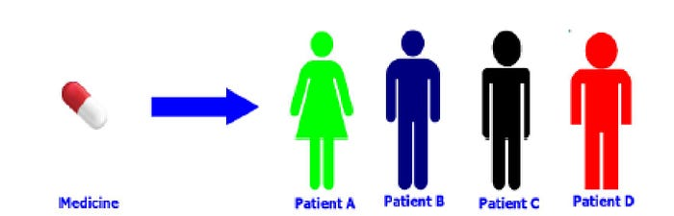

**FIGURE 1**. **Traditional Medicine Approach**

The doctor uses his or her expertise and trial and error method in traditional medicine. The doctor recommends the same medicine with an equal dose, taking into account patients' perceptions of their symptoms. It is not always possible to use this type of treatment. The techniques which benefit the individual victim are weak for all others and, in certain cases, a specific injection may also result in floor effects.

**Health Wearable and Health Monitoring**

**D.) Health Wearable and Health Monitoring**

Any miniaturized electronic device that can be easily worn off the body, or incorporated into clothing or other body accessories, is generally referred to as Wearable Technology, also known as "wearable devices" or simply "wearable". In a healthcare environment, where the utility of wearables has been established in fitness, games and entertainment, there is still little clarity as to their role. Currently, the majority of commercially available wearable devices are limited in scope by monitoring a single or two health related variables and provide no accurate measurement of many quality indicators that they attempt to measure for such as heart rate variability, nutritional status, mood. With the ability to overcome these limitations, wearables are an important tool for a future of precision medicine and their expansion into clinical practice is highly promising in terms of patient specific measures. In different settings, the devices were validated to monitor remote digital health and physical activity. With the widespread use of Physical Activity Monitoring, particularly due to a number of health benefits associated with exercise and many healthcare scenarios where activity information is used clinically, it should come as no surprise that its usefulness continues to be difficult to integrate into medical practice.[15]

**A value proposition for wearable technologies and remote monitoring**

The rapidly expanding availability and advanced nature of mobile health technologies continue to support the promise of oncology care and research. The main technologies of Mobile Health or Mobility are devices allowing you to communicate and transmit data. Mobile phones, to a larger extent smartphones and tablet computers that have sensors for performance, location or biometrics are most frequently used. Wireless connectivity to transmit and store data has recently significantly increased the availability of fitness equipment and sensors on the commercial market as well as consumer adoption. For a period of time, people can keep track of their health with the use of wearables. Recently, wireless connectivity to transmit and store data has significantly increased the commercial availability of fitness equipment and sensors as well as consumers' adoption. Personal health monitoring can be carried out over a prolonged period with the use of wearables. This includes monitoring physical activity, as well as the ambulatory tracking of medically relevant data like ECGs and vital signs.

Remote monitoring can offer cost effectiveness and Scalable options for the use of Wearables and Mobile Technology, which allows patients to be monitored in real time as part of a crucial period of cancer treatment. The use of this technology enables healthcare providers to access objective and patient reporting data so that they can make better decisions with regard to treatment outcomes which could lead to improved adherence, good quality of life and positive therapeutic results. In addition, improving standardization of data collection by gathering more precise and constant information to inform study design and knowledge of medicinal benefits may be achieved with the introduction of cell phones, wearables and sensor applications for medical trials.

**The Future of Wearable Technologies and Remote Monitoring in Health Care**

More and more advances in the development of wearables and remote monitoring equipment are being made. Efforts are ongoing towards developing the next generation of wearables sensors capable of detecting cancer related chemical markers and biomarkers. For example, for rapid skin melanoma screening a wearable bandage and an electroacoustic microneedle platform were developed to detect tyrosinase enzyme's signal on the surface of the skin as well as in moles.

The strong use of artificial intelligence by means of machine learning and data analysis stands in parallel to the pursuit of more tailored, sensitive or reliable devices. It is not only continuous data acquisition but also real time information processing that is enabled by connectivity between devices and the Internet. The newer generation of commercial activity trackers and smartwatches, for example, which offer personal analytical capabilities such as energy consumption and sleep cycles, monitor the body's movements and heart rate.[16]

**Examples of popular wearable devices in healthcare**

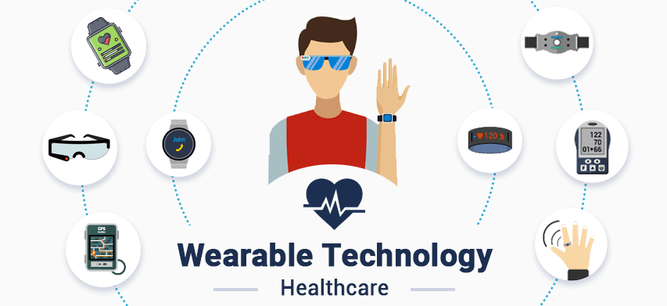

**Figure 3.** Wearable devices for health monitoring.

* **Wearable fitness trackers** - In order to keep track of user's physical activity and heart rate, these bands are equipped with sensors. By synchronizing with other mobile applications, a lot of fitness trackers offer recommendations on health and well-being.
* **Smart health watches** - Smartwatches have evolved to become clinically useful tools for healthcare once they've been just used as a way of tracking steps and time.
* **Wearable ECG monitors** - In the consumer electronics, wearable ECG monitors are becoming an emerging technology. They're capable of recording electrocardiograms or EKGs to help users record their heart rate and heartbeat, as well as measurement of more important physiological parameters such as blood pressure.
* **Wearable blood pressure monitors** - In 2019, Omron Healthcare introduced a new blood pressure monitoring device, the Heart Guide. It takes measurements of blood pressure, daily activity including steps taken and calories burned.
* **Wearable biosensors** - These devices are portable sensors that come in the form of gloves, clothing, bandages and implants. They are designed to give users two ways of feedback with their physician, allowing continuous and noninvasive disease diagnosis and health monitoring from bodily motion biofluids.[17]

**Benefits of wearable technology in healthcare**

One important benefit of wearable technologies in medicine is the ability to monitor patient's physiological state and other healthcare indicators at an instant level. By using wearable tools such as smartwatches and fitness trackers to monitor patients' heart rate, activity levels, sleep patterns or any other aspects of their health, healthcare providers can obtain valuable information about the patient's condition. This information can be applied in order to identify and treat health issues, as well as for the purpose of monitoring patients' progress and adjusting their care if necessary.

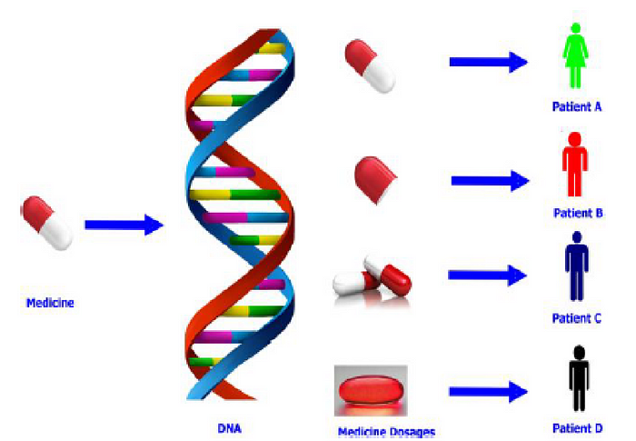Improved patient involvement and empowerment are also an important benefit of wearables in health care. Patients will be more active in their health and well-being through wearing devices that can help them to better understand how they themselves are affected by lifestyle decisions, thereby improving their understanding of their own bodies. It may be a powerful incentive for patients to take better care of themselves, thus enhancing their health outcomes.[18]

**FIGURE 2. Precision Medicine Approach**

Precision medicine is the orientation of clinical strategy towards each patient's specific characteristics. This technique relies on the correct findings in understanding how our patients are sensitive to certain situations because of their unique shape. Our information is further enhanced by the corresponding analysis, so that we can determine whether treatments are reliable and valid in all cases. The physician recommends medicines and dosage according to a person's DNA and medical information, as shown in the figure above.[19]

**How Does Precision Medicine Work?**

**Precision medicine is much more targeted. Scientists have discovered more about genetics behind the disease's origin and how it behaves over years of research.**

**Changes to the genes are associated with a number of diseases. Researchers now have a map of every gene in your body, thanks to the Human Genome Project. They'll see how certain gene changes can lead to illness and what makes someone with heart disease, diabetes or cancer behave differently from another person in terms of treatment. Their knowledge of how genes and illnesses interact could help them to improve the effectiveness of treatments.**

**Doctors can use precision medicine to**:

* **Learn your disease risk.** The type of condition that runs within your family, and the probability you'll get it, can be found by testing your genes.
* **Prevent disease.** If you know you have the gene, you might be able to adjust your lifestyle or seek medical attention to avoid developing sickness. Women who have either an BRCA1 or BRCA2 mutation, for example, are more likely to get breast cancer. They may opt to have operation to remove both of their breasts, known as a mastectomy, to reduce their risk.
* **Find disease**. You can go for a test if you know you are at risk of some kind of disease. The sooner a disease such as cancer is found, the more effectively it can be treated.
* **Target treatments.** Your genetic make-up can guide your doctor to drugs that are most likely to work for you and cause the least side effects. You can even make decisions about how much of a medicine you're supposed to take by using precision medicines.
* **Monitor your response.** In order to assess the effect of treatment on your condition, doctors may employ precision medicine techniques.[20]

**3D PRINTING IN HEALTHCARE**

**E.)** **3D Printing in Healthcare**

**What is 3D Printing in Healthcare?**

3D printing offers tremendous value in healthcare through its ability to create customized solutions, enabling research in various healthcare applications like personalized casts, tissue generation for injury repair, and even the production of fully functional organs with embedded vascular structures.

This technology, also known as additive manufacturing, involves converting a computer-designed 3Dmodel into a tangible three-dimensional object by fusing materials together. It encompasses diverse 3D printing techniques using various materials, including plastics, metals, and even human cells. Layer by layer, it forms intricate shapes and designs that are often unattainable through traditional manufacturing methods.

The personalization capabilities of 3D printing in healthcare empower surgeons to practice and refine their surgical skills using replicated patient organ models, ultimately improving the success of medical procedures. Furthermore, at the nanoscale, healthcare professionals can precisely target drug delivery for more effective and efficient treatments.

**How 3D printing is impacting clinical care**

1. **Implants and Prosthetics**

The benefits of 3D printing in implants and prosthetics encompass the creation of personalized devices that precisely match an individual's unique anatomy, improving comfort and functionality. 3Dprinting facilitates rapid prototype development, expediting design adjustments and testing. Compared to traditional manufacturing, 3D printing significantly reduces lead times, ensuring the prompt delivery of tailored solutions. It excels in producing intricate, complex designs unattainable through conventional methods, driving innovative implant and prosthetic designs. Customized 3D- printed devices lead to enhanced patient outcomes, reduced complications, and improved quality of life. This technology enables patient-specific devices catering to individual needs and fosters ongoing innovation in implant and prosthetic design.

1. **Anatomical Models**

The benefits of 3D printing in anatomical models include creating highly precise and realistic representations of human anatomy, allowing customization for specific patient cases, improving medical training and surgical planning, offering cost-effective production, enhancing patient education, aiding surgeons in procedure planning, supporting medical research and innovation, and enabling rapid model production, ultimately saving time in medical training and healthcare applications.

1. **Medical Equipment**

3D printing has revolutionized the healthcare industry by playing a crucial role in the production of medical equipment. It offers various advantages, including customization, rapid prototyping, and cost- effectiveness. This technology allows for the creation of personalized medical equipment tailored to individual patient needs, particularly benefiting prosthetics, orthopedic implants, and dental devices. Furthermore, it enables rapid prototyping of medical equipment, facilitating quick design iterations and enhancements, which is essential for advancing innovative solutions and improving existing ones. [21]

**GENOME EDITING CRISPR CAS9**

**F.) Genome Editing CRISPR CAS9**

**What is genome editing and CRISPR-Cas9?**

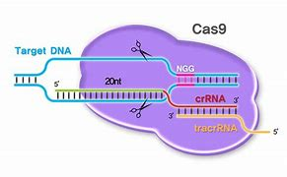

Genome editing, or gene editing, comprises a set of technologies empowering scientists to modify the DNA of organisms. These technologies provide the capability to insert, delete, or change genetic material at specific positions within the genome. Various approaches to genome editing have been devised, with one of the most renowned being the CRISPR-Cas9 system, an acronym for Clustered Regularly Interspaced Short Palindromic Repeats and CRISPR-associated protein 9. CRISPR-Cas9 has garnered significant attention in the scientific community due to its advantages, including speed, cost- effectiveness, precision, and efficiency when compared to other genome editing methods. [22]

**Primary concerns of genome editing**

1. Safety is a primary concern in genome editing due to the potential for off-target effects (edits in unintended locations) and mosaicism (some cells carrying edits while others do not). Experts and ethicists in the field, including participants in the International Summit on Human Gene Editing, generally concur that germline genome editing should not be used for clinical reproductive purposes until it is proven to be safe through research. The potential risks are currently not justified by the anticipated benefits.

2. Informed consent Informed consent preserves an individual's autonomy and their right to decide the fate of their genetic material and future. It guarantees that individuals have the authority to determine if their genetic information is altered and for what objectives. From an ethical and legal perspective, it is imperative to honor individuals' rights and ensure they possess comprehensive awareness of the potential repercussions and dangers linked to genome editing. This aligns with the fundamental principles of medical ethics and human rights.

3. Justice and Equity Genome editing offers promising medical and therapeutic advantages, but there's a worry that these benefits might be limited to individuals who can either financially afford the technology or reside in regions with well-developed healthcare systems. To ensure justice and equity, it is imperative to extend these benefits to a more diverse and inclusive population rather than confining them to a select, privileged few. Neglecting the consideration of justice and equity could exacerbate existing disparities in healthcare access and the availability of medical interventions. Genome editing has the potential to magnify disparities in health outcomes, where individuals with greater financial means gain more extensive access to advanced treatments, leaving others at a distinct disadvantage. [23]

**ROBOTICS IN SURGERY**

**G.) Robotics in Surgery**

**The evolution of surgical robotics**

**The Journey of Robotic Surgery: A Brief Timeline**

**1920s:**

* In the 1920s, the term "robot" was introduced in Karel Capek's play "R.U.R.," envisioning robots as forced laborers leading to humanity's downfall.

**1930-1969:**

* Science fiction explored advanced robots, like Frank Herbert's Dune series with robotic elements.
* The BBC aired "Doctor Who" episodes featuring Cybermen in 1966, adding to the fascination.

**1970s:**

* NASA and the U.S. Defense Research Advanced Projects Agency explored telesurgery for astronauts and battlefield medicine, laying the groundwork.

**1980s:**

* The first surgical robot, PUMA 560, participated in a brain biopsy in 1985.
* 1988:
* The PROBOT from Imperial College London aided transurethral prostate surgery in 1988.

**1990s:**

* ROBODOC prepared the femur for hip replacement surgery in 1992.
* The da Vinci Surgical System and other laparoscopic surgical robots emerged.

**2000s:**

* In 2001, telesurgery achieved a milestone with the Lindinburg Surgery, though latency challenges persisted.
* The Zeus system pioneered various surgeries but was succeeded by the da Vinci Surgical System after Computer Motion's acquisition.

**2010s:**

* The da Vinci Surgical System gained prominence, even peeling a grape's skin in a whimsical yet impressive demonstration in 2010.

**Definition of Robotic Surgery**

Robotic surgery, often referred to as robot-assisted surgery, offers doctors the ability to perform a wide range of intricate procedures with greater precision, flexibility, and control compared to conventional methods. Typically associated with minimally invasive surgery, which involves small incisions, robotic surgery is also occasionally employed in specific traditional open surgical procedures.

The primary clinical robotic surgical system in use comprises a camera arm and mechanical arms equipped with surgical tools. From a computer console located near the operating table, the surgeon commands these arms. This console provides the surgeon with a high-definition, magnified, three-dimensional view of the surgical area. The surgeon leads a team of other medical professionals who provide assistance throughout the procedure.

**Robotic Surgery System**

**Top Robotic Surgery Systems**

1**. da Vinci (Intuitive Surgical):**

- FDA-cleared for general laparoscopic surgeries in 2000.

- Enables precise minimally invasive procedures in various specialties.

- Surgeon operates from a console, commanding robotic devices on the patient cart.

- Over 1,700 systems worldwide; 75% of U.S. prostate cancer operations.

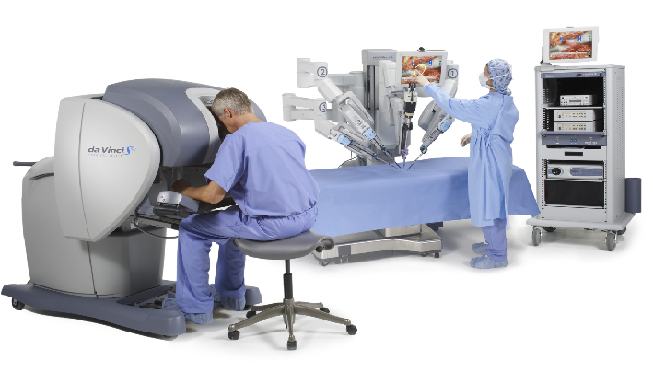

2. **Ion (Intuitive Surgical):**

- Obtained FDA clearance in 2019.

- Designed for precise lung biopsies in challenging areas.

- Robotic catheter navigates lung airways, secures position, and enables precise biopsies.

- Offers a 180° range of motion for fine-tuned precision.

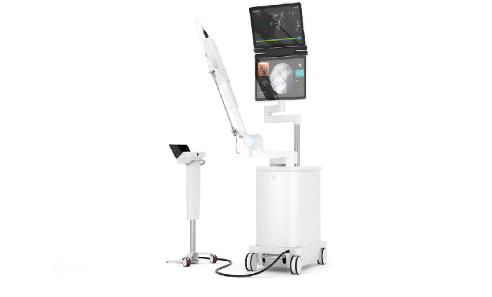

3**. Mako (Stryker):**

- Supports partial knee, total hip, and total knee surgeries.

- Uses CT scan data to create a 3D model and individualized implant plan.

- Data integration during surgery allows for real-time adjustments.

- Acquired Mako Surgical Corp. in 2013 for $1.65 billion.



4. **NAVIO (Smith & Nephew):**

- FDA-cleared in 2018 for total knee replacement.

- Performs bone mapping during surgery to create a 3D bone model.

- Robotic hand tool guides the procedure based on real-time data.

- Offers VR training simulations for surgeons.

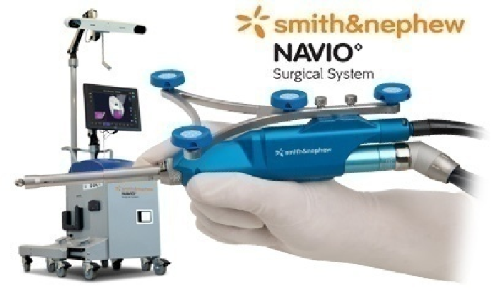

5**. Monarch (Auris Health):**

- FDA-cleared in 2018 for lung endoscopic procedures.

- Employs a video game-like controller for precise navigation.

- Integrates bronchoscope vision with computer-guided 3D models.

- Acquired by Johnson & Johnson's Ethicon subsidiary in 2013 for $3.4 billion.

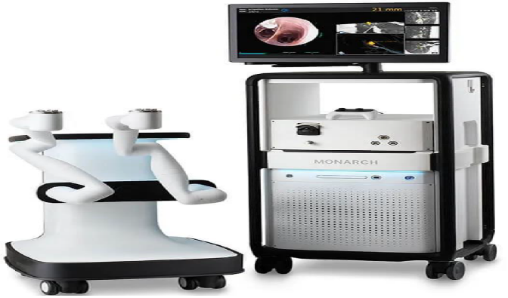

**Robotic Assisted Surgery**

Surgical robots are transforming the medical field, enabling safer and less invasive procedures. They can work alongside or independently of surgeons, ushering in an era of minimally invasive surgeries, which lead to quicker patient recovery and reduced infection risks. However, they come at a high cost and require specialized surgeon training.Laparoscopy marked the initial step in minimally invasive surgery, but it had limitations like lacking depth perception and challenging hand-eye coordination. Surgical robots aim to address these shortcomings by providing precision, sterility, and the potential for remote tele-surgery, including military applications (Hussain & Malik, 2014).

Surgical robots fall into two categories: passive and active. Passive robots, like the PUMA 200, determine needle entry points accurately but require manual control. They find applications in neurosurgery and orthopedics due to consistent anatomy. Active robots, exemplified by ROBODOC and daVinci, possess more autonomy. ROBODOC autonomously performs orthopedic surgeries with mixed results. DaVinci is tele-operated, enhancing hand-eye coordination and precise movement mimicry, although it lacks haptic feedback. The text also mentions untethered microsurgeons like capsule endoscopes, useful for non-invasive GI tract exploration. In this evolving field, surgical robots promise to revolutionize patient care, ensuring safer, less invasive, and more precise surgeries.

**Advantages of Robotics in Surgery**

**Robotic surgery offers significant advantages:**

1. Precision
2. Surgeon Benefits
3. Access to Challenging Areas
4. Advanced Visualization
5. Optimal Performance
6. Staff Well-Being

**Challenges and Ethical Considerations**

1. High cost
2. Movement Latency
3. Steep learning curve
4. Potential mistakes

Robotic surgery offers new possibilities in the field of surgery. However, it demands specialized training, quality assessment, and experience to ensure high-quality care. Legal implications can be complex, potentially involving the physician, hospital, and the robotic system manufacturer in case of adverse outcomes. Ethical considerations revolve around equipment safety, information provision, and confidentiality. The cost of robotic surgery and limited access in public hospitals may restrict broader adoption of this technology.

**Success Story**

St. Luke’s performs first Transoral Robotic Surgery in PH

Doc pioneers minimally invasive robotic surgery

**Future of Robotics in Surgery**

The outlook for robotic surgery in healthcare is promising, with several potential advancements on the horizon. Some forecasts for the upcoming years include:

Further refinement of advanced and versatile robotic surgical systems capable of conducting a broader range of procedures with enhanced precision and accuracy.Integration of artificial intelligence and machine learning into robotic surgery systems to facilitate more personalized and efficient surgical procedures.Advancements in virtual reality and augmented reality technologies that could enhance surgeons' visualization and manipulation of surgical sites.Greater adoption of robotic surgery systems in developing nations where the technology is currently less accessible.The future of robotic surgery is anticipated to yield significant improvements in surgical outcomes, reduced recovery times, and heightened patient satisfaction.

**VIRTUAL REALITY IN THERAPY**

**H.) Virtual Reality in Therapy**

**History of Virtual Reality in Therapy**

Virtual Reality (VR) is a complex concept, aiming to trick our brains into perceiving something as real. An anecdote about an early cinematic screening illustrates this challenge, where viewers mistook a train on screen for a real one. Today, VR refers to computer-generated immersive experiences with an emphasis on interactivity. However, not all VR is interactive, and some non-computer-generated media resembles VR.

VR has a historical context beyond its formalization, influencing other media like film. Its development has led to various technological directions, with milestones sometimes focused on establishing ideas rather than inventing specific technologies. This history explores VR's evolution and the pioneers who shaped it.

**The development of virtual reality (VR) in therapy spans several decades:**

Early Exploration (1960s-1970s): VR's potential therapeutic applications began to emerge, initially in exposure therapy for phobias.

Exposure Therapy Growth (1980s-1990s): VR's role in controlled exposure therapy expanded, targeting various phobias.

PTSD Treatment:VR exposure therapy became a tool to address post-traumatic stress disorder (PTSD).

Pain Management and Rehabilitation (2000s-2010s): VR assisted in pain distraction during medical procedures and enhanced physical rehabilitation.

Mental Health Focus:VR played a role in treating mental health conditions, offering immersive cognitive-behavioral therapy (CBT).

ASD Support:VR helped individuals with autism improve social skills through controlled scenarios.

Recent Progress: VR has become more accessible and integrated into therapy, especially with the growth of telehealth during the COVID-19 pandemic.

Continued Research: Ongoing studies explore VR's efficacy in diverse therapeutic applications, promising further advancements.

VR in therapy has evolved significantly, offering innovative ways to address mental health, phobias, pain, and rehabilitation, with potential for future growth.

**Harnessing VR for therapeutic purposes and Applications in mental health**

1. **Exposure Therapy:** VR is used for treating phobias, PTSD, and anxiety disorders by creating controlled, immersive environments where patients can confront their fears safely.
2. **Pain Management:** VR serves as a distraction during medical procedures and pain management, helping alleviate discomfort through immersive experiences.
3. **Physical Rehabilitation:** In physical therapy, VR creates engaging exercises and activities to aid patients in regaining mobility and enhancing motor skills after injuries or surgeries.
4. **Mental Health Treatment:** VR is applied in various therapeutic approaches, including CBT, to address conditions like depression, anxiety, and phobias by providing interactive scenarios.
5. **Stress Reduction:** VR environments promote relaxation and stress reduction, with guided meditation and mindfulness exercises in virtual settings offering mental wellness benefits.
6. **ASD Support:** VR assists individuals with ASD in improving social and communication skills through safe virtual social interactions.
7. **Telehealth and Remote Therapy:** VR facilitates telehealth by enabling therapists to conduct virtual sessions with clients remotely, which is especially useful during the COVID-19 pandemic.
8. **Personalized Therapy:** VR can be tailored to meet individual needs, providing customized therapeutic experiences that adapt to each patient's unique requirements.
9. **Research and Advancements:** Ongoing research explores new applications of VR in therapy, spanning a wide range of mental health disorders and physical conditions.

**How VR Therapy Works?**

Virtual reality (VR) therapy engages sensory and cognitive processes:

1. Sensory Input: VR provides visual, auditory, and haptic feedback.
2. Immersive Environment**: It creates a realistic world for a sense of presence.
3. Exposure Therapy: Users confront fears or anxieties in a controlled space.
4. Controlled Environment: Therapists tailor the experience, gradually increasing intensity.
5. Realistic Feedback: The brain reacts as if it's real, causing emotional and physiological responses.
6. Cognitive Techniques: Therapists guide users through strategies to manage emotions.
7. Neuroplasticity: Repeated exposure and cognitive interventions can rewire the brain.
8. Biofeedback: Monitoring physiological responses helps manage emotions.
9. Generalization: Users apply learning from VR to real-life situations.
10. Treatment Progression: Therapy advances from less to more challenging scenarios.

VR therapy leverages immersive, controlled experiences and cognitive interventions to benefit mental health by tapping into the brain's ability to adapt.

**Enhancing patient engagement:**

To improve patient engagement in virtual reality therapy, consider these strategies:

1. **Personalized Therapy:** Customize VR experiences to fit each patient's needs, boosting relevance and involvement.
2. **Interactivity:** Create VR environments that respond to patient actions, making therapy more immersive.
3. **Progress Tracking:** Use VR to visually show patients their progress, motivating them to continue therapy.
4. **Gamification:** Add game elements like rewards and challenges to make therapy more engaging.
5. **Realistic Simulations:** Develop lifelike VR scenarios related to the patient's condition for emotional connection.
6. **Patient Empowerment:** Encourage patients to set goals and make choices in VR, promoting engagement.
7. P**ositive Reinforcement:** Give instant positive feedback in VR to reinforce desired behaviors.
8. **Social Interaction:** Enable multiplayer or social VR experiences when suitable, fostering a sense of community.
9. **Safety and Comfort:** Ensure patients feel safe and comfortable during VR therapy.
10. **Education and Support:** Provide clear instructions, training, and continuous support for VR use.
11. **Diverse Experiences:** Include various VR experiences to prevent monotony.
12. **Feedback Loop:** Gather patient feedback to improve therapy.
13. **Measurable Goals:** Set clear, measurable session goals.
14. **Patient-Centered Approach:** Involve patients in therapy program design.
15. **Stay Updated:** Keep current with VR tech and therapy techniques.

Implementing these strategies can enhance patient engagement in virtual reality therapy, leading to better outcomes and a more motivating therapy experience.VRET involves the integration of virtual reality (VR) technology with exposure therapy. In this method, professionals use a VR headset to simulate various triggers, stressors, or fears that an individual may have. These simulations can include visual, auditory, olfactory, and tactile stimuli, replicating realistic versions of traumatic or stressful experiences.

**Evidence-based outcomes**

**Real-Life Case: Treating PTSD with VR Exposure Therapy**

John, a military veteran suffering from severe post-traumatic stress disorder (PTSD), underwent VR exposure therapy as a treatment option. A VR simulation recreated his traumatic experiences over several weeks. This immersive therapy resulted in:

Symptom Reduction: John experienced fewer nightmares and flashbacks.

Improved Coping: He developed effective coping strategies during VR scenarios.

Enhanced Quality of Life: His overall well-being improved, allowing him to rebuild relationships.

Treatment Adherence: John remained engaged and motivated throughout VR therapy.

Long-Term Benefits: Even after therapy, John continued to benefit from reduced symptoms.

This real-life example underscores the effectiveness of VR therapy in treating PTSD, offering a safe platform for individuals to manage their mental health challenges and improve their lives. Please note that VR therapy outcomes can vary individually.

**Another case example:**

Real-Life Case: Stroke Rehabilitation with VR Gaming

Sarah, a 45-year-old stroke survivor with right-arm weakness, utilized VR gaming as part of her rehabilitation. Key outcomes included:

Improved Arm Function: Sarah's VR sessions significantly enhanced her right arm's motor function, enabling her to perform daily tasks better.

Motivation Boost: VR's gamified exercises motivated Sarah, increasing her enthusiasm for rehabilitation compared to traditional methods.

Enhanced Mobility: VR encouraged Sarah to use her arm more extensively, improving its range of motion and flexibility.

Independence Regained: As her arm improved, Sarah regained independence in activities like dressing and meal preparation.

Emotional Well-being: Engaging with VR gaming not only helped her physically but also emotionally, fostering a sense of achievement and enjoyment.

Sustained Progress: Even after formal therapy, Sarah continued using VR gaming to maintain and further enhance her motor skills.

This real-life example showcases the potential of VR-based rehabilitation, combining gamification and interactivity to drive physical recovery and patient motivation. It demonstrates VR's value as an engaging and effective tool in stroke rehabilitation.

**Pros and Cons of Virtual Reality in Therapy**

1. Controlled and Secure Environment: VR therapy provides a secure and controlled space for exposure therapy, permitting individuals to confront their fears and anxieties without real-world consequences.
2. Tailored Experiences: Therapists can personalize VR experiences to meet the specific requirements of each person, gradually increasing the intensity of exposure as therapy advances.
3. Heightened Engagement: The immersive nature of VR can amplify engagement and motivation during therapy, leading to increased focus on treatment exercises.
4. Private Settings: VR therapy can be administered in a private setting, reducing the social stigma often associated with traditional face-to-face therapy.
5. Repeatable Sessions: VR sessions are easily repeatable, allowing individuals to practice coping strategies and desensitization multiple times.
6. Neuroplasticity Benefits: VR therapy can facilitate the rewiring of the brain by creating new neural pathways, ultimately resulting in decreased anxiety and improved mental well-being.
7. Real-time Biofeedback: VR technology can offer immediate biofeedback data, enabling therapists to monitor progress and make data-driven decisions regarding treatment.

**Cons of Incorporating Virtual Reality into Therapy:**

1. Financial Costs: High-quality VR equipment can be expensive, potentially limiting access for some individuals and treatment centers.
2. Technical Challenges: Technical problems, such as motion sickness or system malfunctions, can disrupt therapy sessions and lead to discomfort.
3. Limited Generalization: Gains achieved in VR therapy may not always transfer to real-world situations, leaving individuals to struggle with their fears or anxieties beyond the virtual environment.
4. Compatibility Issues: VR therapy may not be suitable for everyone, particularly those with specific medical conditions, disabilities, or sensory sensitivities.
5. Therapist Training Requirements: Therapists may need training to effectively utilize VR technology in therapy, which can be both time-consuming and costly.
6. Ethical Considerations: Ethical concerns, including data privacy and informed consent, require meticulous attention in VR therapy practices.
7. Absence of Human Connection: While VR can create an immersive experience, it cannot replace the personal connection and rapport-building inherent in traditional face-to-face therapy.
8. Overreliance on Technology: There is a potential risk of individuals becoming overly reliant on technology for treatment and neglecting other vital therapeutic and coping strategies.

Incorporating virtual reality into therapy holds promise, especially for exposure therapy and certain anxiety-related disorders. Nevertheless, it is accompanied by a series of challenges and limitations. Its appropriateness for specific individuals should be assessed on a case-by-case basis, with therapists and healthcare providers carefully weighing the advantages and disadvantages to determine the most effective treatment approach.

**NANOMEDICINE**

1. **Nanomedicine**

**Short History of Nanomedicine**

Nanomedicine, blending nanotechnology and medicine, aims to transform healthcare with innovative disease diagnosis, treatment, and prevention methods. Its roots date to the early 20th century when nanoparticle potential in medicine was explored. In the 1950s and 1960s, researchers delved into using nanoparticles for drug delivery, enhancing therapeutic effectiveness. Coined by physicist Richard Feynman in 1959, the term "nanomedicine" gained momentum in the 1990s due to rapid nanotechnology advances.

A pivotal moment occurred in 1995 with FDA approval of Doxil, the first nanoparticle-based drug for AIDS-related Kaposi's sarcoma, spurring further research. Nanoparticles and nanostructured materials have since been studied for targeted drug delivery, imaging agents, biosensors, tissue engineering, and cancer therapy. Nanomedicine holds promise for precise, personalized healthcare, early disease detection, and improved patient outcomes, with ongoing research poised for groundbreaking innovations.

**Father of Nanomedicine**

Richard Feynman, a renowned physicist, is not directly associated with nanomedicine. However, his influential 1959 lecture, "There's Plenty of Room at the Bottom," is considered a foundational moment in the conceptual development of nanotechnology. This lecture introduced the idea of manipulating matter at the nanoscale and laid the groundwork for the broader field of nanotechnology.

Nanomedicine, a subset of nanotechnology, uses principles from nanoscience and nanotechnology to address medical and healthcare challenges. While Richard Feynman's lecture helped establish the theoretical underpinnings for working at the nanoscale, the practical applications of nanomedicine in healthcare and medicine have been developed by scientists and researchers in the field of medicine, pharmacy, and nanoscience.



**Nario Taniguchi**

As of my last knowledge update in September 2021, Nario Taniguchi was not widely recognized in the field of nanomedicine. It's conceivable that he may have made contributions to nanomedicine subsequent to that date, although I lack access to information beyond that timeframe. Nanomedicine is a swiftly advancing domain with input from researchers and experts from diverse backgrounds, and fresh developments and contributors may emerge over time. To explore any recent information or advancements concerning Nario Taniguchi and his involvement in nanomedicine after September 2021, it is advisable to refer to the most up-to-date sources or scholarly publications for the latest insights.



**K.Eric Drexler**

K. Eric Drexler is a notable figure in the wider domain of nanotechnology, particularly in the realm of molecular nanotechnology. Although he has made significant contributions to the theoretical underpinnings of nanotechnology, his work is not directly linked to the field of nanomedicine.

Drexler is most renowned for his influential publication, "Engines of Creation," in which he delved into the potential of molecular nanotechnology, including the notion of constructing intricate structures atom by atom. His work has established the theoretical groundwork for the overall development of nanotechnology, but the practical applications of nanomedicine have predominantly evolved through the efforts of medical, pharmaceutical, and nanoscience experts.

As of my last knowledge update in September 2021, Drexler's focus was primarily on the broader possibilities of nanotechnology rather than its specific applications in the realm of healthcare. It's worth noting that the field of nanomedicine is a multidisciplinary endeavor, with contributions coming from a diverse array of specialists. Drexler's primary recognition lies in his contributions to the theoretical and conceptual aspects of nanotechnology. For the latest information on any potential developments or specific contributions by K. Eric Drexler to nanomedicine after September 2021, it is advisable to refer to the most current sources.



**Nanoscale**

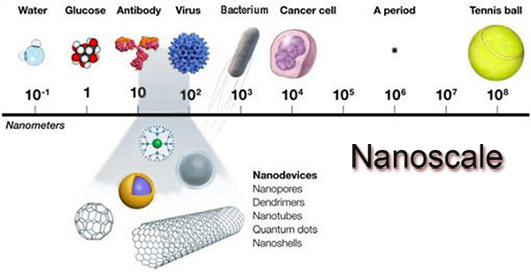

**Types of Nanoparticles**

**Organic Type Nanoparticles**

Organic nanoparticles, specifically liposomes and polymers, are essential components in drug delivery, nanomedicine, and various other applications. Here's an overview of each:

1. **Liposomes:**

**Composition**: Liposomes are spherical vesicles composed of a lipid bilayer. This bilayer structure consists of phospholipids, making them organic nanoparticles.

**Applications**:

**Drug Delivery**: Liposomes are widely used as drug carriers to encapsulate a variety of therapeutic agents. Their structure allows for the encapsulation of hydrophilic and hydrophobic drugs, making them versatile drug delivery vehicles.

**Targeted Therapy:** Liposomes can be functionalized with specific ligands or antibodies to target particular cells or tissues, enabling precision in drug delivery.

**Imaging:** Liposomes are used as contrast agents in medical imaging to enhance the visibility of tissues and organs in diagnostics.

**Benefits:** Liposomes offer improved drug solubility, controlled drug release, reduced side effects, and enhanced therapeutic efficacy.

**2) Polymeric:**

**Composition:** Polymeric nanoparticles are made from biocompatible and biodegradable polymers, which are organic materials.

**Applications:**

**Drug Delivery:** Polymeric nanoparticles are used to encapsulate drugs, genes, or other therapeutic agents. They are engineered to enable controlled drug release and can improve drug solubility and stability.

**Gene Delivery:** These nanoparticles can serve as gene carriers in gene therapy, delivering genetic material to target cells.

**Tissue Engineering:** Polymeric nanoparticles are integrated into biomaterials for tissue engineering applications, promoting cell adhesion, proliferation, and differentiation.

**Benefits:** Polymeric nanoparticles are biocompatible and biodegradable, making them suitable for various medical applications. They can be tailored to provide controlled and sustained drug release.

Both liposomes and polymeric nanoparticles are fundamental components in the development of advanced drug delivery systems, diagnostic agents, and therapies in the field of nanomedicine. Their organic nature, biocompatibility, and versatility have contributed to their widespread use in healthcare and biotechnology.

**Inorganic Type Nanoparticle**s

Inorganic nanoparticles encompass a diverse range of materials, including metallic nanoparticles, metal oxide nanoparticles, and quantum dots. Here's an overview of each:

**1) Metallic Nanoparticles:**

**Composition:** Metallic nanoparticles are composed of various metal elements, such as gold, silver, platinum, or iron, at the nanoscale.

**Applications:**

**Catalysis:** Metallic nanoparticles are used as catalysts in chemical reactions due to their high surface area and reactivity.

**Biosensing:** They are employed in biosensors for detecting biomolecules and pathogens.

**Imaging:** Metallic nanoparticles are used as contrast agents in imaging techniques like CT scans and MRI.

**Drug Delivery:** Some metallic nanoparticles can serve as drug carriers for targeted drug delivery.

Cancer Therapy: Gold nanoparticles, for example, can enhance the effectiveness of radiation therapy in cancer treatment.

**Benefits:** Metallic nanoparticles have unique optical, electrical, and catalytic properties that make them valuable in various applications.

**2) Metal Oxide Nanoparticles:**

Composition: Metal oxide nanoparticles are composed of metal and oxygen atoms. Common examples include iron oxide (Fe3O4), titanium dioxide (TiO2), and zinc oxide (ZnO) nanoparticles.

**Applications:**

**Magnetic Resonance Imaging (MRI):** Iron oxide nanoparticles are used as contrast agents in MRI for imaging and diagnosing diseases.

**Sunscreen:** Titanium dioxide and zinc oxide nanoparticles are used in sunscreens to provide UV protection.

**Catalysis:** Metal oxide nanoparticles are employed as catalysts in chemical reactions.

**Environmental Remediation:** They are used to remove contaminants from water and soil.

**Benefits:** Metal oxide nanoparticles exhibit diverse properties and are used in environmental, medical, and industrial applications.

**3) Quantum Dots:**

Composition: Quantum dots are semiconductor nanoparticles typically made of elements like cadmium, selenium, or indium.

**Applications:**

**Biological Imaging:** Quantum dots are used in biological imaging due to their bright and tunable fluorescence properties. They can track and visualize cellular processes.

**Quantum Dot Displays:** They are employed in display technologies, offering vibrant colors and energy-efficient displays.

**Solar Cells:** Quantum dots are used in solar cells to enhance light absorption and energy conversion.

**Benefits:** Quantum dots are prized for their unique optical properties, including size-tunable emission wavelengths, making them valuable in imaging and display technologies.

Inorganic nanoparticles, including metallic, metal oxide, and quantum dots, are at the forefront of scientific research and technological advancements. Their properties and applications span a wide spectrum, contributing to innovations in fields like medicine, electronics, and materials science.

**Carbon Based Nanoparticles**

Carbon-based nanoparticles, specifically nanotubes and fullerenes, belong to a category of nanoscale materials primarily consisting of carbon atoms. These nanoparticles possess distinctive attributes and find utility in various applications:

1. **Carbon Nanotubes (CNTs):**

- Structure: CNTs exhibit a cylindrical configuration formed by the rolling of graphene sheets. They exist as either single-walled (SWCNTs), composed of a single layer, or multi-walled (MWCNTs), featuring multiple concentric layers.

- **Applications:** CNTs have a broad spectrum of uses, spanning nanoelectronics, materials science, and nanocomposite development. Their remarkable mechanical strength and electrical conductivity make them instrumental in advancing cutting-edge materials and devices.

2. **Fullerenes:**

- Structure: Fullerenes take on a unique form, presenting closed-cage, spherical carbon molecules, with the prevalent C60 variant known as buckminsterfullerene bearing a resemblance to soccer balls, with a composition of hexagonal and pentagonal facets.

- **Applications:** Fullerenes have diverse applications in drug delivery, diagnostics, and materials science. They possess the capability to encapsulate drugs or molecules within their hollow structure, thus serving as potential carriers for drug delivery. Their distinctive cage-like structure enables the entrapment and conveyance of various compounds.

Both carbon nanotubes and fullerenes play pivotal roles in nanotechnology, offering extensive opportunities for advancements in materials, electronics, drug delivery, and a multitude of other domains.

**Challenges:**

Nanomedicine has great potential for transforming healthcare but faces significant challenges, including:

1. **Safety and Toxicity:** Ensuring the safety of nanomaterials is a top concern, as some nanoparticles may have unknown toxic effects.

2. **Regulation and Standardization:** Clear regulations and standardized testing are needed to ensure the safety and efficacy of nanomedicine products.

3**. Biocompatibility:** Developing nanoparticles that are compatible with human tissues and organs is a substantial challenge.

4. **Targeted Delivery:** Precise delivery of nanoparticles to specific cells or tissues is a challenge.

5**. Stability and Manufacturing:** Maintaining nanoparticle stability during storage and production is a complex task.

6. **Cost and Accessibility:** The high costs of development may limit accessibility, particularly in resource-limited settings.

7. **Ethical and Social Concerns:** Ethical considerations, such as privacy and informed consent, must be addressed.

8. **Resistance and Adaptation**: Microorganisms may develop resistance to nanomedicines, requiring strategies to prevent and manage resistance.

9. **Interdisciplinary Collaboration:** Collaboration between different disciplines is essential but challenging.

10. **Scale-Up and Translation:** Scaling up production and conducting large clinical trials pose significant obstacles.

Addressing these challenges is crucial to fully realize the potential of nanomedicine for healthcare improvement. Ongoing efforts by researchers and regulators aim to find solutions while ensuring safety and efficacy.

**Application of Nanomedicine**

Nanomedicine finds a wide array of uses in the realm of healthcare and medicine. Some of the principal applications encompass:

1. **Drug Delivery:**

- Nanoparticles can be tailored to encapsulate and transport medications to specific body targets. This targeted drug delivery enhances treatment efficacy while minimizing side effects.

2. **Cancer Treatment:**

- Nanoparticles are harnessed to deliver chemotherapy drugs directly to cancer cells, minimizing harm to healthy cells and elevating overall treatment effectiveness.

3. **Imaging and Diagnosis:**

- Medical imaging methods like MRI, CT scans, and ultrasound employ nanoparticles as contrast agents. Additionally, they're instrumental in early disease detection and diagnostics.

4. **Vaccines:**

- Nanoparticles enhance vaccines by bolstering delivery, amplifying immune responses, and furnishing controlled antigen release.

5. **Wound Healing:**

- Advanced wound dressings and materials for tissue regeneration, facilitating faster and more efficient wound healing, are made possible by nanomedicine.

6. **Neurological Disorders:**

- Tailored nanoparticles are engineered to traverse the blood-brain barrier, permitting targeted treatment of neurological conditions like Alzheimer's and Parkinson's.

7. **Gene Therapy:**

- Gene therapy employs nanoparticles for the delivery of therapeutic genes to specific cells, holding potential for addressing genetic diseases.

8. **Cardiovascular Health:**

- Drug delivery to the cardiovascular system and treatments for conditions such as atherosclerosis and heart disease benefit from nanoparticle technology.

9. **Dental Health:**

- Nanomedicine contributes to the development of dental materials, including nanocomposites for fillings and agents combating dental infections.

10. **Regenerative Medicine:**

- Nanotechnology plays a pivotal role in tissue engineering and regenerative medicine, participating in the construction of artificial organs and scaffolds for tissue regeneration.

11. **Antibacterial Agents:**

- Nanoparticles are employed in crafting materials and coatings with antimicrobial properties, aiding in the fight against drug-resistant bacteria.

12. **Ophthalmology:**

- Nanomedicine serves to create drug delivery systems for eye conditions and enhance the bioavailability of ophthalmic medications.

13. **Chronic Disease Management:**

- Controlled drug release systems designed with nanomedicine are valuable in managing chronic conditions like diabetes and hypertension.

14. **Cosmetic and Aesthetic Medicine:**

- The cosmetic industry benefits from nanomedicine in skincare products and procedures such as dermal fillers and skin rejuvenation.

15**. Environmental Health:**

- Nanomedicine applications extend to environmental remediation, enabling the removal of contaminants and pollutants from water and soil.

These examples illustrate how nanomedicine is transforming healthcare and medicine by offering more precise and effective treatments, early disease detection, and improved patient outcomes. The field continues to advance rapidly, with ongoing research and innovations expanding its applications.

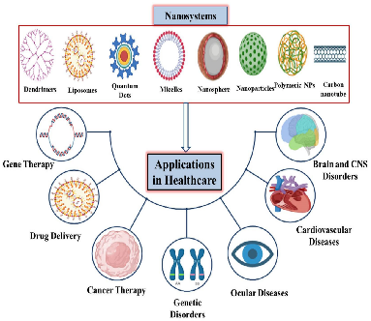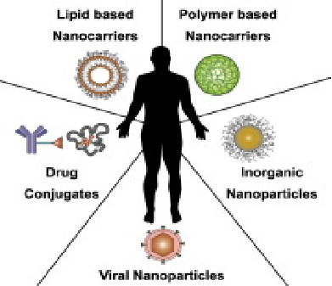

**SUMMARY**

 **REFERENCES**

1. Voshmgir, S. (2020, June). Token Economy.

<https://blockchainhub.net/blockchain-intro/>

1. Jha, S. (2023). The complete guide for types of

blockchain! *Simplilearn.com*. <https://www.simplilearn.com/tutorials/blockchain-tutorial/types-of-blockchain#types_of_blockchain>

1. Arora, S. (2023). What is cryptocurrency: types, benefits, history

and more. *Simplilearn.com*. <https://www.simplilearn.com/tutorials/blockchain-tutorial/what-is-cryptocurrency>

1. Frankefield, J. (2023, August 29). Cryptocurrency Explained with Pros

and Cons for Investment. <https://www.investopedia.com/terms/c/cryptocurrency.asp>

1. FAQ - Bitcoin. (n.d.).

<https://bitcoin.org/en/faq#what-are-the- advantages-of-bitcoin>

1. Governance | UNIsWAP Protocol. (n.d.). Uniswap

Protocol. <https://uniswap.org/governance>

1. Solana | There are no bad questions about. blockchain basics.

(n.d.). <https://solana.com/learn/blockchain-basics>

1. mstoken.art. (2022, January 29). Invest - mstoken.art. mstoken.art –

a Fine Art Security Token. <https://mstoken.art/invest/>

1. Phugger. (2021, July 1). Most countries have failed to implement the

FATF’s travel rule - blockchain. Blockchain. <https://blockchain.bakermckenzie.com/2021/07/01/most-countries-have-failed-to-implement-the-fatfs-travel-rule/>

1. El Salvador Adopts Bitcoin as Legal Tender. (n.d.). International

Trade Administration | Trade.gov. <https://www.trade.gov/market-intelligence/el-salvador-adopts-bitcoin-legal-tender>

1. CoinMarketCap. (n.d.). Cryptocurrency Prices, Charts And Market

Capitalizations | CoinMarketCap. <https://coinmarketcap.com/>

1. Freeman Law. (2022, October 18). Japan - Cryptocurrency Laws and

Regulation Freeman Law. <https://freemanlaw.com/cryptocurrency/japan/>

[13] Center for Devices and Radiological Health. (2018). Precision medicine. *U.S. Food And Drug Administration*. https://www.fda.gov/medical-devices/in-vitro-diagnostics/precision-medicine

[14] Naithani, N., Sinha, S., Misra, P., Vasudevan, B., & Sahu, R. (2021). Precision medicine: Concept and tools. *Medical Journal Armed Forces India*, *77*(3), 249–257. https://doi.org/10.1016/j.mjafi.2021.06.021

[15] Watson, S. (2018, May 30). *Traditional vs. Precision Medicine: How They Differ*. WebMD. <https://www.webmd.com/cancer/precision-vs-traditional-medicine>

[16] Jain, K. (2021, December 15). Artificial Intelligence for Precision Medicine and better Healthcare. *Medium*. https://medium.com/analytics-vidhya/artificial-intelligence-for-precision-medicine-and-better-healthcare-ccfda9595aff

[17] Smuck, M., Odonkor, C. A., Wilt, J. K., Schmidt, N., & Swiernik, M. A. (2021). The emerging clinical role of wearables: factors for successful implementation in healthcare. *Npj Digital Medicine*, *4*(1). https://doi.org/10.1038/s41746-021-00418-3

[18] Smuck, M., Odonkor, C. A., Wilt, J. K., Schmidt, N., & Swiernik, M. A. (2021). The emerging clinical role of wearables: factors for successful implementation in healthcare. *Npj Digital Medicine*, *4*(1). https://doi.org/10.1038/s41746-021-00418-3

[19] Phaneuf, A. (2021, May 26). 5 examples of popular wearable devices in healthcare. *Business Insider*. https://www.businessinsider.com/5-examples-wearable-healthcare-devices-2021-5

[20] LifeSigns. (n.d.). The benefits of wearable technology in healthcare. *www.linkedin.com*. <https://www.linkedin.com/pulse/benefits-wearable-technology-healthcare-life-signs>

[21] 3 Ways 3D printing is revolutionizing health care | AHA. (2022, June 7). American Hospital Association. <https://www.aha.org/aha-center-health-innovation-market-scan/2022-06-07-3-ways-3d-printing-revolutionizing-health-care>

[22] What are genome editing and CRISPR-Cas9?: MedlinePlus Genetics. (n.d.). <https://medlineplus.gov/genetics/understanding/genomicresearch/genomeediting/>

[23] Nhgri. (2019, March 13). What are the Ethical Concerns of Genome Editing? Genome.gov. <https://www.genome.gov/about-genomics/policy-issues/Genome-Editing/ethical-concerns>

[24] Introduction to robotic surgery - dr. Mangesh Patil. (n.d.). <https://www.drmangeshpatil.com/wp-content/uploads/2018/04/Introduction-to-Robotic-surgery.pdf>

[25] Levinson, K. (n.d.). *Robotic Assisted Surgery | Electrical and Computer Engineering Design Handbook*. <https://sites.tufts.edu/eeseniordesignhandbook/2015/robotic-assisted-surgery/>

[26] Codete. (2023, November 17). *Are robotic surgeries better? Pros and Cons of Robotic surgery*. Codete Blog. <https://codete.com/blog/robotic-and-robot-assisted-surgery>

[27] *History Of Virtual Reality - Virtual Reality Society*. (2020, January 2). Virtual Reality Society. <https://www.vrs.org.uk/virtual-reality/history.html>

[28] *(VR) Virtual Reality therapy for Mental health | XRHealth*. (2023, October 20). XRHealth. <https://www.xr.health/virtual-reality-therapy/>

[29] Edward, C. (2023). Unleashing the potential of nanotechnology in regenerative medicine for healthcare. *Longdom*. <https://doi.org/10.4172/2155-983X.23.13.202>

[30] Singh, S. P. (2010). Nanomedicine–Nanoscale drugs and delivery systems. *Journal of Nanoscience and Nanotechnology*, *10*(12), 7906–7918. <https://doi.org/10.1166/jnn.2010.3617>

**LEARNING ACTIVITY**

1. Which term is something used interchangeably with precision medicine?
2. Standard medicine
3. Average medicine
4. General medicine
5. Personalized medicine

Answer: D

1. What advancements have precision medicine already achieved?
2. Enhance disease prevention strategies
3. FDA-approved medicines customized to individual features
4. Improved diagnostic tools for all diseases
5. Advancements in surgical techniques

Answer: B

1. Which concept did Sir William Osler emphasize in relation to precision medicine?
2. Knowing what sort of a patient has disease
3. Knowing the genetic makeup of a patient
4. Knowing the environment factors affecting a patient
5. Knowing what sort of a disease a patient has

Answer: A

1. What is wearable technology?
2. A device that can be easily worn off the body
3. A device that can be incorporated into clothing
4. A device used for fitness, games, and entertainment
5. A device that monitors heart rate variability

Answer: A

1. Why is it difficult to integrate physical activity monitoring into medical practice?
2. Due to a lack of health benefits associated with exercise
3. Due to the limited availability of wearable devices
4. Due to the complexity of integrating activity information clinically
5. Due to the lack of patient-specific measures

Answer: C